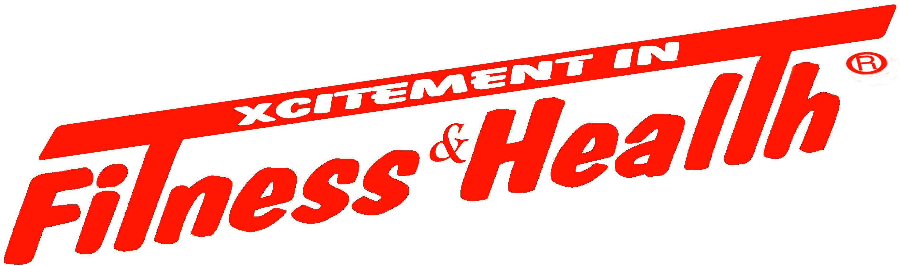
Fitness and Health Magazine

12200 Ford Road
Dallas, TX 75234
Phone 972-869-0144 Fax 972-869-0147

ADVERTISING AGREEMENT

CLIENT NO. _____________________

BUSINESS _______________________________________ BUS. PHONE ( ) _____________________

TYPE OF BUSINESS ______________________________________ FAX ( ) _____________________

ADDRESS ____________________________________ CITY ___________________ ST ___ ZIP ________

MAILING ADDRESS ___________________________ CITY ___________________ ST ___ ZIP ________

E-MAIL ADDRESS ____________________________________ CLIENT PHONE ( ) _______________

Fitness and Health Magazine, LLC will provide Layout, Typesetting, Ad Proof and all Printing.

AD SIZE _____________________

START DATE _____________________

END DATE _____________________

COST _____________________

COMMITMENT DISCOUNT _____________________

EXTRAS _____________________

TOTAL COST _____________________

50% DUE TODAY _____________________

50% DUE UPON AD PROOF _____________________

I AUTHORIZE Fitness and Health Magazine to charge my credit card on _______ day of each month.

____ VISA ____ MC ____ AMEX ____ DISC ACCT. NO. __________________________________

EXP. DATE: ____________ NAME: _________________________________________________________

AGREEMENT CONDITIONS:
1. The Advertiser named above specifically authorizes and gives Fitness and Health Magazine permission to distribute the above specified material. The Advertiser further agrees to honor the offer made to each recipient of the material.
2. If there is a mistake made in the copy of the ad, the Advertiser agrees that Fitness and Health Magazine’s liability hereunder shall not exceed an amount equal to the total consideration actually paid hereunder to by the Advertiser to Fitness and Health Magazine.
3. If specific ink colors are requested, Fitness and Health Magazine will try to accommodate. However, Fitness and Health Magazine will not be held financially responsible if it is unable to provide preferred ink color(s).
4. The cancellation of any printing is subject to a cancellation fee of $100.00 payable by the advertiser.
5. Returned checks are subject to a $25.00 charge
6. Any balance within this agreement that goes unpaid 30 days or more past the due date will result in cancellation of all future printings listed in this contract.
7. In the event Fitness and Health Magazine places this agreement in the hands of an attorney or collection agency for collection, the Advertiser agrees to pay an additional sum equal to 33% of the balance then due to compensate Fitness and Health Magazine for costs of collection, including, but not limited to, attorney’s fees or collection agent’s fees.
I hereby represent and warrant that I have the authority to sign this agreement on behalf of Advertiser.

__________________________________________ _____________________________________ ______________
SIGNATURE PRINT NAME DATE
Sales person ____________________________ New Client______ Source _________________________________________

